Carpenter – Passionate Kisses
Original key: D Us: Same practice intro
YAM: piano1 Dmaj blues scale 412312

Intro Piano
Verse melody [2x]
[VERSE]
D | A | bm | G [2x]
D | f#m | bm | G
[CHORUS] D | G [3X]
Verse melody [1x]
[BRIDGE] with melody
Verse [break on last bar]
Chorus [last bar punches on G]
Chorus [elide into melody]
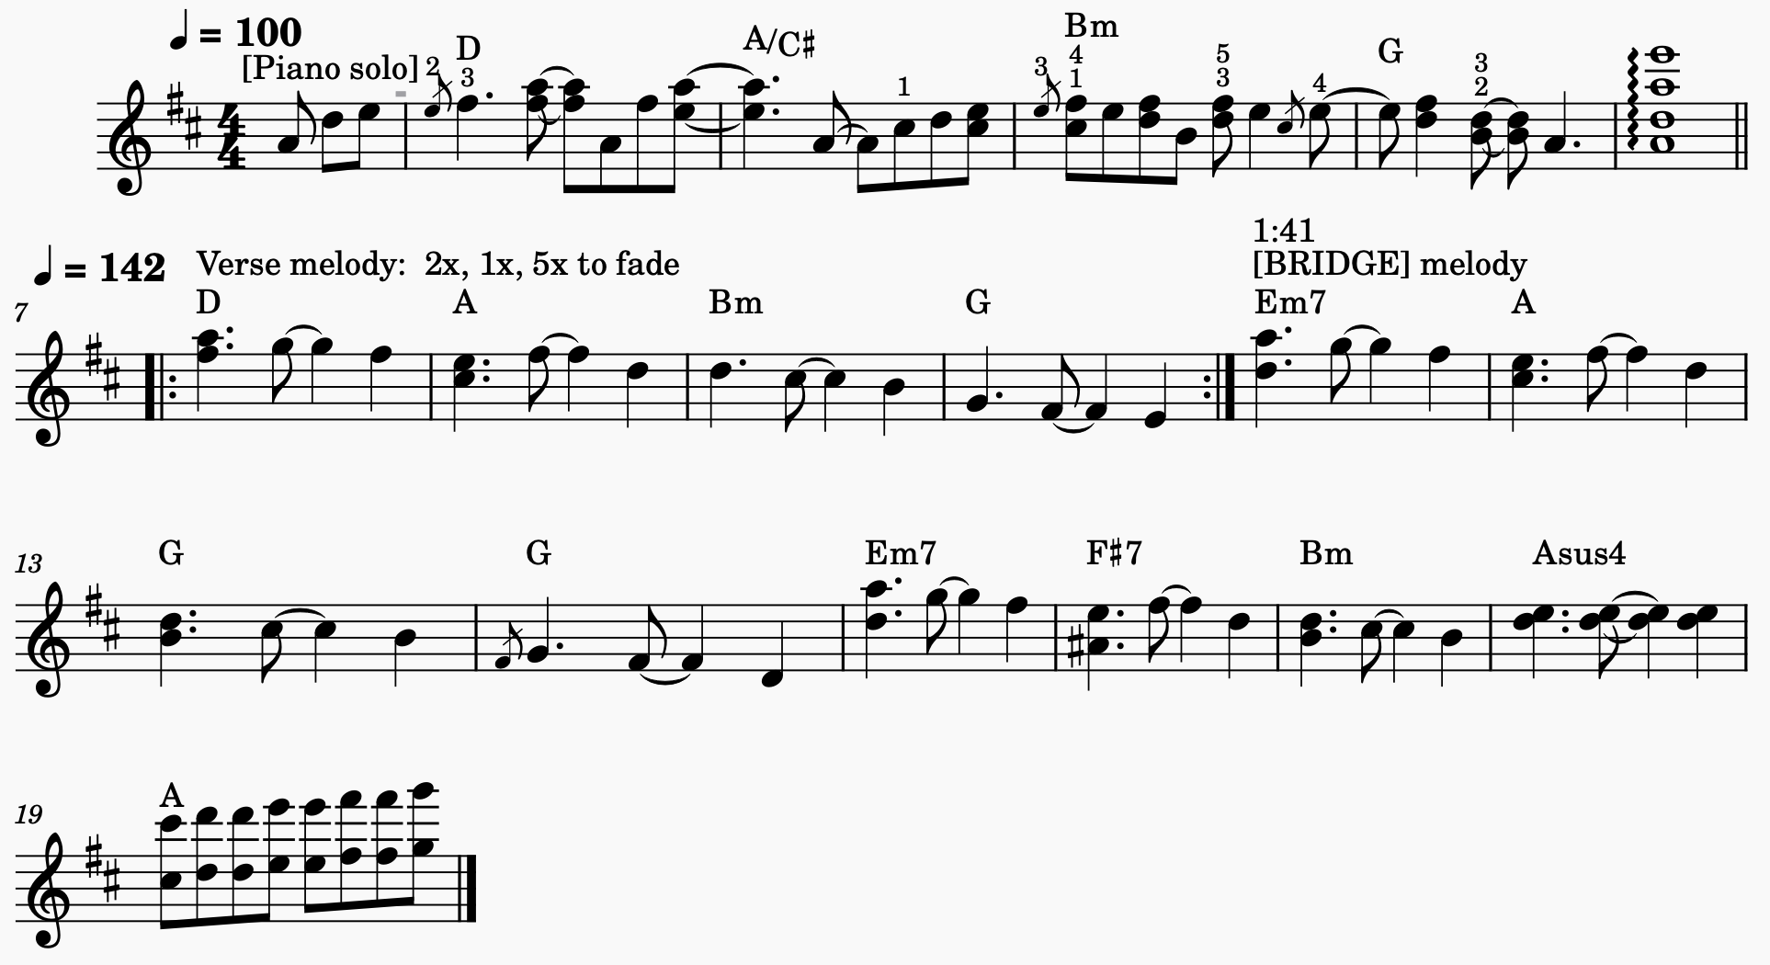
Verse melody [5x over chorus]

